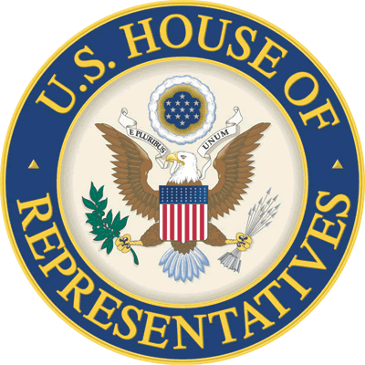

Congressman Larry Bucshon
Internship Application

Personal Information:

Name: ________________________________________________________________________
(First) (Middle) (Last)

Current Address: _______________________________________________________________
(Street Address)

____________________________________________ ________ _______________________
(City) (State) (Zip)
Permanent Address: _____________________________________________________________
(Street Address)

____________________________________________ ________ _______________________
(City) (State) (Zip)
Phone Number: ______________________ Alternate Phone Number: ____________________

Date of Birth: _______/________/________

Email Address: _________________________________________________________________

Internship Information:

Please check the desired location of your internship.

____ Washington, D.C. _____ Evansville, IN _____Terre Haute, IN

Please check the desired session of your internship.

____Spring Session/January-May ____Summer Session-1/May-June
Deadline is November 15th Deadline is March 15th

____Summer Session-2/July-August ____Fall Session/September-December
Deadline is May 15th Deadline is July 15th

Education Information:

College: ______________________________________________________________________

____Freshman ____Junior ____Sophomore ____Senior

Major: __________________________________ Minor: _______________________________

High School Attended: ____________________________________ G.P.A.: ______________

Extracurricular Activities: ________________________________________________________

______________________________________________________________________________

Writing Sample:

Please answer all of the following questions in a separate document.

- Briefly list the areas of public policy that most interest you and explain why those particular issues are important to you.

- Briefly describe what you expect to learn from an internship with Congressman Bucshon and how you envision yourself contributing to our office.

- Describe your greatest strength and weakness.

- Describe your career goals.
- What do you believe the role is of the federal government?

Letters of Recommendation:

Internships require two letters of recommendation.

- ________________________________________________________________________
(Name) (Relationship)

- ________________________________________________________________________
(Name) (Relationship)

Please fax or mail your resume and cover letter with all of the required documents to the office in which you are applying.

Washington, DC
Attn: Intern Coordinator
1123 Longworth HOB
Washington, DC 20515
Phone: (202) 225-4636
Fax: (202) 225-3284

Evansville Office
Attn: Intern Coordinator
101 NW Martin Luther King Jr. Blvd., Room 124
Evansville, IN 47708
Phone: (812) 465-6484
Fax: (812) 422-4761

Terre Haute Office
Attn: Intern Coordinator
901 Wabash Avenue, Suite 140
Terre Haute, IN 47807
Phone: (812) 232-0523
Fax: (812) 232-0526

