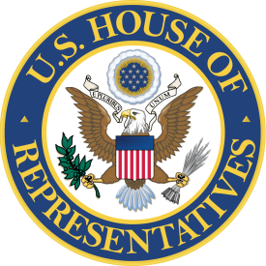

United States Service Academy Application Checklist

Congressman Larry Bucshon, MD
20 NW 3rd Street, Suite 1230
Evansville, IN 47708
Phone: (812) 465-6484
To be considered for a nomination to one of the United States Service Academies by Congressman Larry Bucshon, your packet must be received by the Evansville District Office or via email by Friday, October 4, 2024. Your completed file must contain the following:
- Completed Application Form
- High School Transcript- Your transcript must include all course work, GPA, and class rank.
- Standardized Test Scores- Please provide scores for the ACT or SAT, or both. We will accept official high school transcripts with the scores listed, or scores sent by the ACT or SAT.
- Letters of Recommendation- Students must provide at least 3 letters of recommendation (no more than 5). Examples include High School Principal, Guidance Counselor, Teacher, Coach, or an individual (non- relative) who is aware of your abilities and desire to attend an academy.

- Community & School Activity List- Please list all school, athletic, and community activities and other significant accomplishments/awards.
- Interview- All applicants will be required to attend an interview session during the months of November or December, conducted by our Academy Nomination Advisory Committee. Dates, times, and locations will be determined at a later date.
- Essay- Please provide an essay (300 words or less) outlining why you want to attend a United States Service Academy.
- Deadline- Send the above information by Friday, October 4, 2024.
Please make sure to begin the pre-candidate file with each academy to which you plan to send an application. These nomination materials are SEPARATE from the materials you must provide to the academies. If you have any questions, please the Evansville District Office at (812) 465-6484.

